COAL LAB TASKS 9
Task 1:
include Irvine32.inc

.data
num dword ?
msg1 byte "Enter a number: ",0
msg2 byte "Enter key: ",0
msg3 byte "Encrypted number: ",0
msg4 byte "Decrypted number: ",0

.code
main proc
mov edx,offset msg1
call writeString
call readInt
mov num,eax
mov edx,offset msg2
call writeString
call readInt
mov cl,al
mov ebx,num
shl ebx,cl
mov eax,ebx
mov edx, offset msg3
call writeString
call writeInt
call crlf
shr ebx,cl
mov eax, num
mov edx, offset msg4
call writeString
call writeInt

exit
main endp
end main
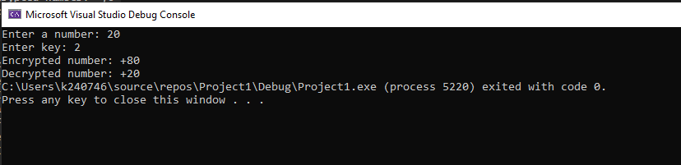

Task 2:
include Irvine32.inc

.data
num1 dword ?
num2 dword ?
msg1 byte "Enter number 1: ",0
msg2 byte "Enter number 2: ",0
msg3 byte "After using add:: ",0
msg4 byte "After using adc: ",0
msg5 byte "After using sub: ",0
msg6 byte "After using sbb: ",0

.code
main proc
mov edx,offset msg1
call writeString
call readInt
mov num1,eax
mov edx,offset msg2
call writeString
call readInt
mov num2,eax
add eax,num1
mov edx,offset msg3
call writeString
call writeInt
call crlf
stc
mov eax,num1
adc eax,num2
mov edx,offset msg4
call writeString
call writeInt
call crlf
mov eax,num1
sub eax,num2
mov edx,offset msg5
call writeString
call writeInt
call crlf
stc
mov eax,num1
sbb eax,num2
mov edx,offset msg6
call writeString
call writeInt
exit
main endp
end main

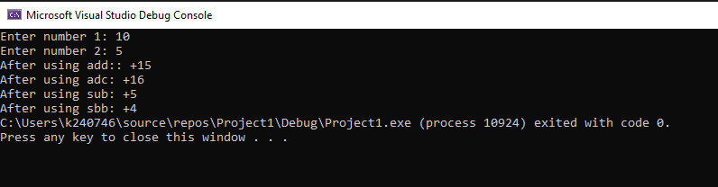
Task 3:
INCLUDE Irvine32.inc

.data
num1 SBYTE ?
num2 SWORD ?

msg1 BYTE "Enter the first negative number: ", 0
msg2 BYTE "Enter the second negative number: ", 0

msg3 BYTE "Byte to Word conversion: ", 0
msg4 BYTE "Word to Dword conversion: ", 0
msg5 BYTE "Original size of number 1: ", 0
msg6 BYTE "Extended size of number 1: ", 0
msg7 BYTE "Original size of number 2: ", 0
msg8 BYTE "Extended size of number 2: ", 0

.code
main PROC
mov edx, OFFSET msg1
call WriteString
call ReadInt
mov num1, al

mov edx, OFFSET msg2
call WriteString
call ReadInt
mov num2, ax

mov al, num1
cbw
movsx eax, ax
mov edx, OFFSET msg3
call WriteString
call WriteInt
call Crlf

mov edx, OFFSET msg5
call WriteString
mov eax, TYPE num1
call WriteInt
call Crlf

mov edx, OFFSET msg6
call WriteString
mov eax, TYPE ax
call WriteInt
call Crlf
call Crlf

mov ax, num2
cwd
movsx eax, ax
mov edx, OFFSET msg4
call WriteString
call WriteInt
call Crlf

mov edx, OFFSET msg7
call WriteString
mov eax, TYPE num2
call WriteInt
call Crlf

mov edx, OFFSET msg8
call WriteString
mov eax, TYPE eax
call WriteInt
call Crlf

exit
main ENDP
END main
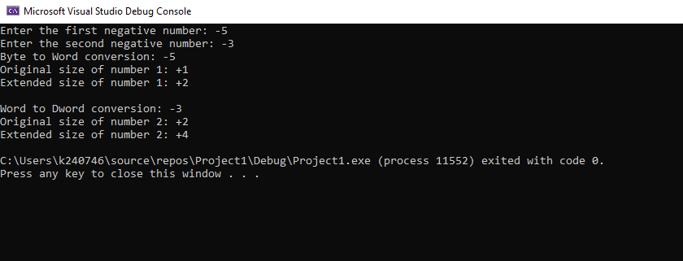
Task 4:
include Irvine32.inc

.data
num dword ?
n byte ?
msg1 byte "Enter a number: ",0
msg2 byte "Enter value of n: ",0
msg3 byte "After multiplication: ",0
msg4 byte "After division: ",0

.code
main proc
mov edx, offset msg1
call writeString
call readInt
mov num,eax
mov edx,offset msg2
call writeString
call readInt
mov n,al
mov ebx,num
mov cl,n
shl ebx,cl
mov eax,ebx
mov edx,offset msg3
call writeString
call writeDec
call crlf
mov ebx,num
shr ebx,cl
mov eax,ebx
mov edx,offset msg4
call writeString
call writeDec

exit
main endp
end main
